Report 9, Neuroelectronics

Seqian Wang, In Collaboration with Sulantha Mathotaarachchi and Maxime Parent

# 1) Passive Model

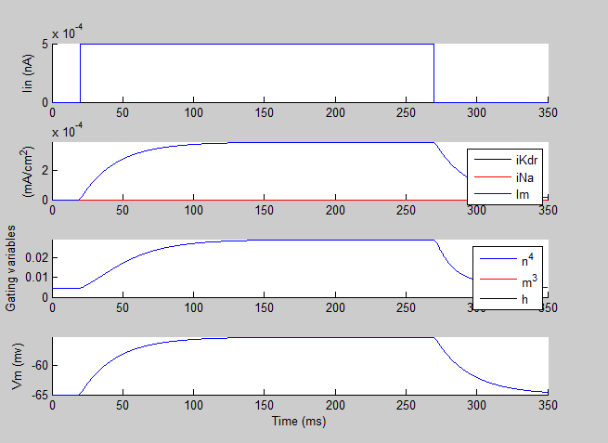

Figure 1: Time Course Response to a 0.5pA Current Injection

## Time Course from the Response

The time constant can be calculated as the time it takes to reach 63% of the maximum response. Here, it is reached at ~52ms. Thus,

$$τ=52-20=32ms$$

## Time Course from the Parameters

$$τ=RC=25000Ω×cm^{2}×1\frac{μF}{cm^{2}}=25ms$$

## Hyperpolarizing Current

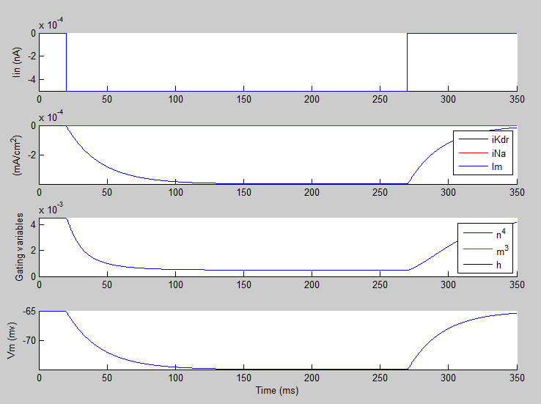

Figure 2: Time Course Response to a -0.5pA Current Injection

The injected current hyperpolarizes the cell. Using the same eye-ball method, the time constant appears unchanged (32ms).

# 2) Effects of a voltage-dependent K conductance KDR

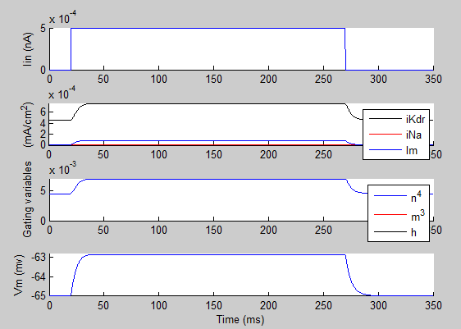

Figure 3: Time Course Response to a 0.5pA Injected Current with Voltage-dependent K channels

The neuron membrane potential reaches equilibrium much more rapidly in response to a current injection. The time potential is around 7ms. By having potassium channels, the membrane conductance is a lot higher, and the equilibrium is reached a lot faster. Note: the equilibrium reached is much lower than the one without potassium channels. This is because the equilibrium potential for K channels is -90mV, so their contribution is hyperpolarizing.

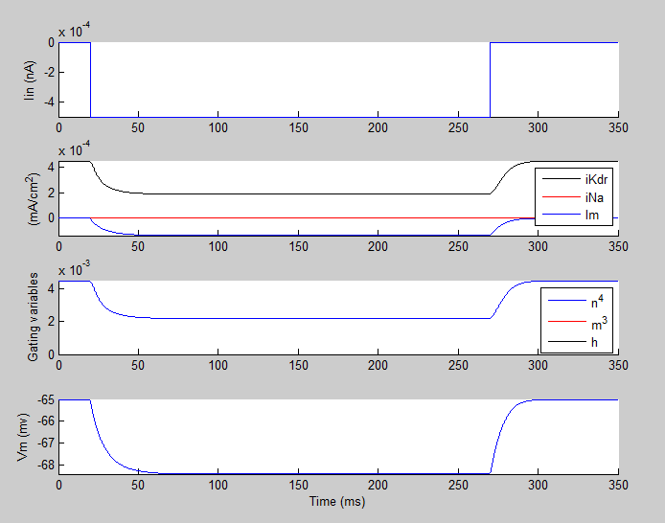

Figure 4: Time Course Response to a -0.5pA Injected Current with Voltage-dependent K channels

The time constant is around 12ms. Looking at Subplot 2 in Figure 4, the negative current reduces the potassium conductance and inverts the passive conductance (negative instead of positive), in contrast with a positive current. As the total conductance is smaller, the membrane potential response to a current is slower.

# 3) Add in a voltage-dependent Na conductance to produce action potentials

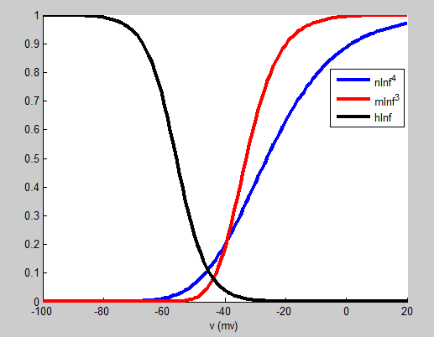

Figure 5: Gating Functions for the Sodium Channels, Potassium Channels and the Passive Membrane

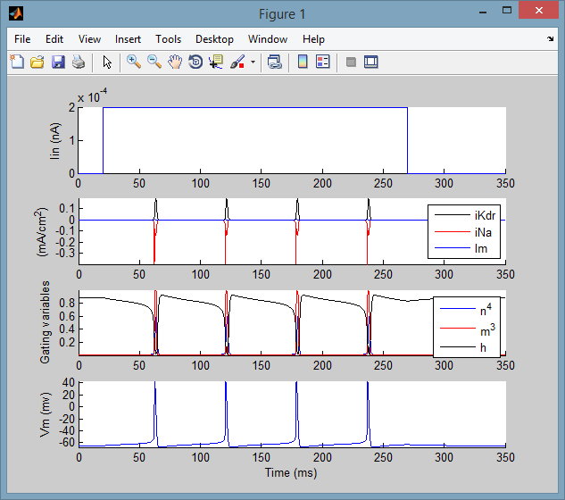

Figure 6: Time Course Response to a 0.2pA Injected Current with Voltage-dependent K channels and Na channels

An action potential is produced when the membrane potential depolarizes and reaches a certain threshold, after which a lot of sodium channels open and the sodium channel conductance increases substantially. In response, the potassium channels conductance increase too, albeit at a slower rate, bringing the voltage back below the threshold, and back to the resting potential.